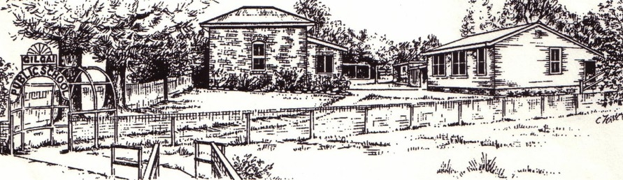 President: Angie Ellis Secretary: Tessa Monckton Treasurer: Erica Black
Gilgai P&C Association
Gilgai Creek
Gilgai 2360
ABN 16637152113

Gilgai Public School uniform pricelist

Short sleeve school polo shirt | $35.00
Unisex rugby knit shorts 4 – 16Y | $12.00
Unisex rugby knit shorts S – 3X | $15.00
Jacket 4 – 16Y | $20.00
Jacket S – 3X | $25.00
Tracksuit pants 4 – 16Y  Tracksuit pants S – 2X | $15.00  $20.00
Dry & Cosy jacket 4 – 16Y | $35.00
Dry & Cosy jacket S – 3X | $40.00
Poly/cotton bucket hats | $ 7.00
Socks | $ 3.00

Parent/Caregiver Name___________________________________________

Child/s Name ___________________________________________

ITEM | PRICE | QTY | Size | TOTAL
Short sleeve school polo shirt | $35.00
Unisex rugby knit shorts 4 – 16Y | $12.00
Unisex rugby knit shorts S – 3X | $15.00
Jacket 4 – 16Y | $20.00
Jacket S – 3X | $25.00
Tracksuit pants 4 – 16Y | $15.00
Tracksuit pants S – 2X | $20.00
Dry & Cosy jacket 4 – 16Y | $35.00
Dry & Cosy jacket S – 3X | $40.00
Poly/cotton bucket hats | $ 7.00
Socks (single pair) 2-8, 9-12, 13-3 | $ 3.00
TOTAL COST

I have enclosed $_________

Signed__________________________________ Dated_________________

